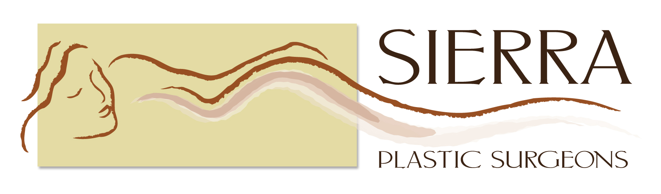
1105 E. Spruce Ave., Ste 203.
Fresno, CA 93720
T (559) 256-7700 ▪ F (559) 256-7711

ATTENTION: MEDICAL RECORDS

Appt. Date with New/Referred Physician: (Month/Day/Year) ___________________

Authorization for Use or Disclosure of Health Information

This authorization for use or disclosure of my health information is required by state and federal law.

(PATIENT NAME-PLEASE PRINT ) (TODAY’S DATE)

I HEREBY AUTHORIZE MY HEALTH INFORMATION TO BE RELEASED FROM:

Clinic or Doctor: ______________________________________________________________

Address:_____________________________________________________________________

City, State, Zip: ______________________________________________________________

I HEREBY AUTHORIZE MY HEALTH INFORMATION TO BE RELEASED TO:

Sierra Plastic Surgeons:
Kaye M. Riolo, M.D.
John F. Burnett, M.D.

1105 E. Spruce Ave., Ste 203
Fresno, CA. 93720

This authorization applies to the following information:
[ ] Any part of my medical record from (enter dates) ________________________________

[ ] The following records or types of information (include dates of treatment): ___________________________________________________________________________

The recipient may use my health information only for the following purposes:
[ ] Continuing health care [ ] Other ______________________________________________
Expiration: [ ] 6-months from date of signing [ ] Other: ____________________________

(Cont on Back)
Authorization for Use or Disclosure of Health Information
Page 2

Restrictions:
California law prohibits the recipient from making further disclosure of your health information unless the recipient obtains another authorization from you or unless the disclosure is required or permitted by law. This protection does not extend to recipients outside the State of California.

Your Rights:
- I may refuse to sign this authorization and my refusal will not affect my ability to obtain treatment or payment.
- I may revoke this authorization at any time. My revocation must be in writing, signed by me or on my behalf, and delivered to this address:

My revocation will be effective upon receipt, but will have no impact on uses or disclosures made while my authorization was valid.
- I have a right to receive a copy of this authorization.
If this box [ ] is checked, copy was requested and received. Initials _________
- I may inspect and obtain a copy of health information that I am authorizing for use or disclosure.
- If this box [ ] is checked, Sierra Plastic Surgeons will receive compensation for the use or disclosure of my health information.

Your Signature:

_______________________________________________ ______________________
(PATIENT’S SIGNATURE) (DATE OF BIRTH)

_______________________________________________ ______________________
(PHONE NUMBER) (SOCIAL SECURITY NO.)

_______________________________________________ ______________________
(SIGNATURE OF PARENT, GUARDIAN, OR (DATE)
AUTHORIZATION REPRESENTATIVE OF PATIENT)

